Enrollment Directions for the 2018-19 School Year

- Go to http://stjosephtampa.org. Click on the RenWeb link at the top of the page or the word “RenWeb” under Welcome! Ir a http://stjosephtampa.org. Haga clic en el RenWeb enlace en al parte superior de la página o la palabra RenWeb en Welcome!
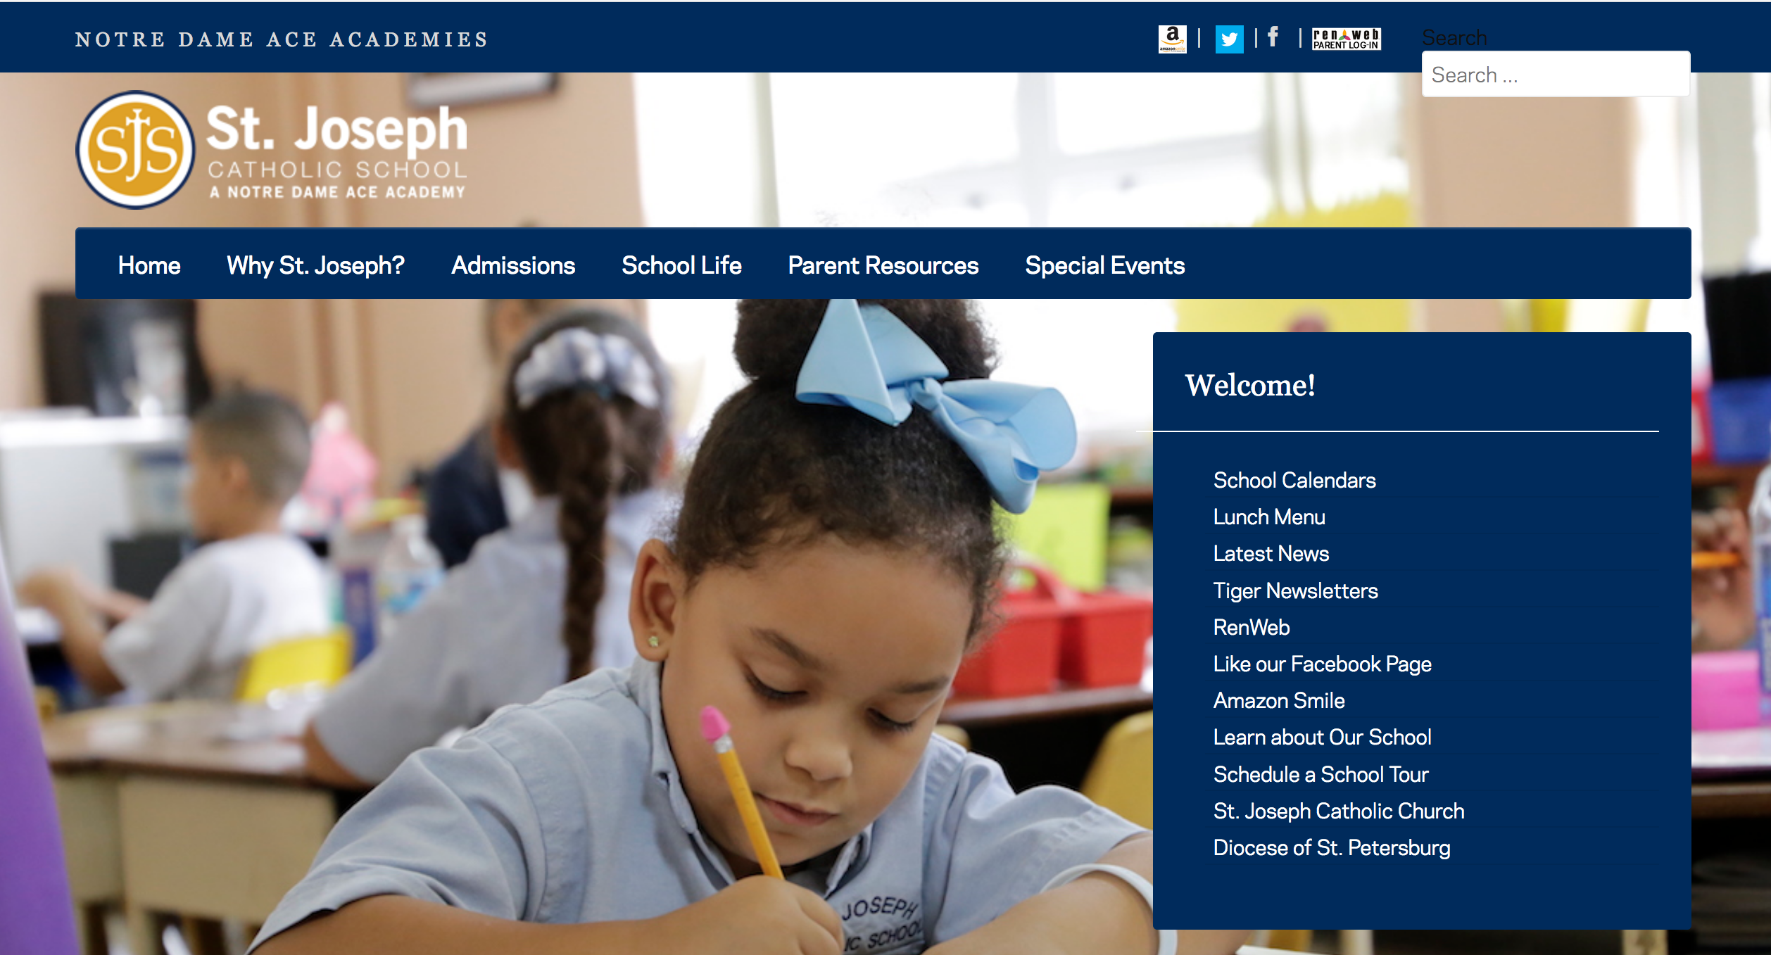

- Login to your account. If you do not have an account, click “Create New ParentsWeb Account” and follow the instructions. Ingresa a tu cuenta. Si no tiene una cuenta, haga clic en "Create New ParentsWeb Account" y siga las instrucciones.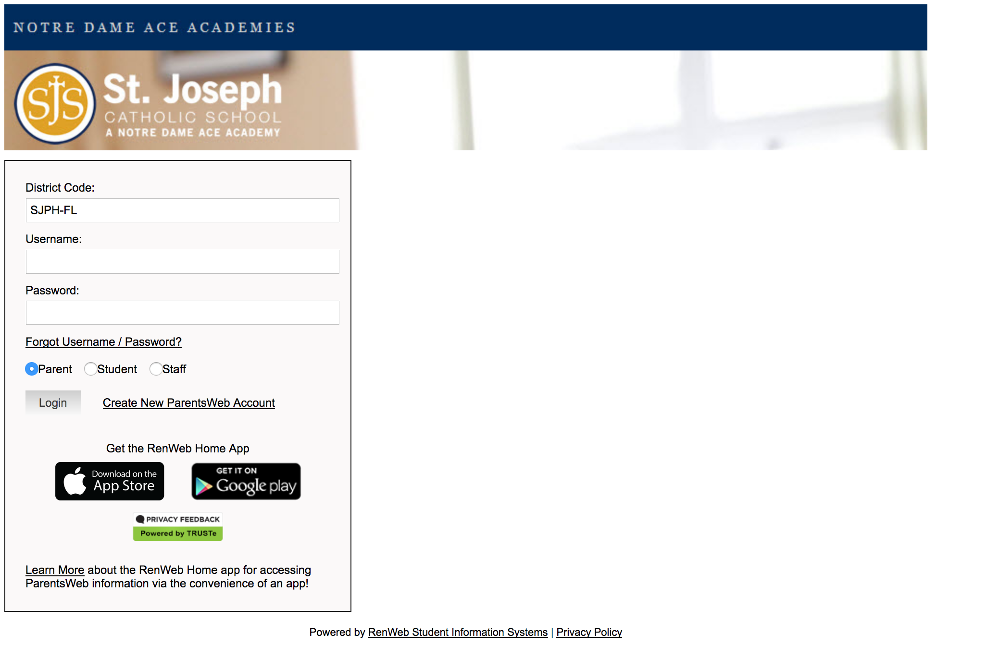
- Click Family Information, then Enrollment/Reenrollment. Haga clic Family Information, y después Enrollment/Reenrollment.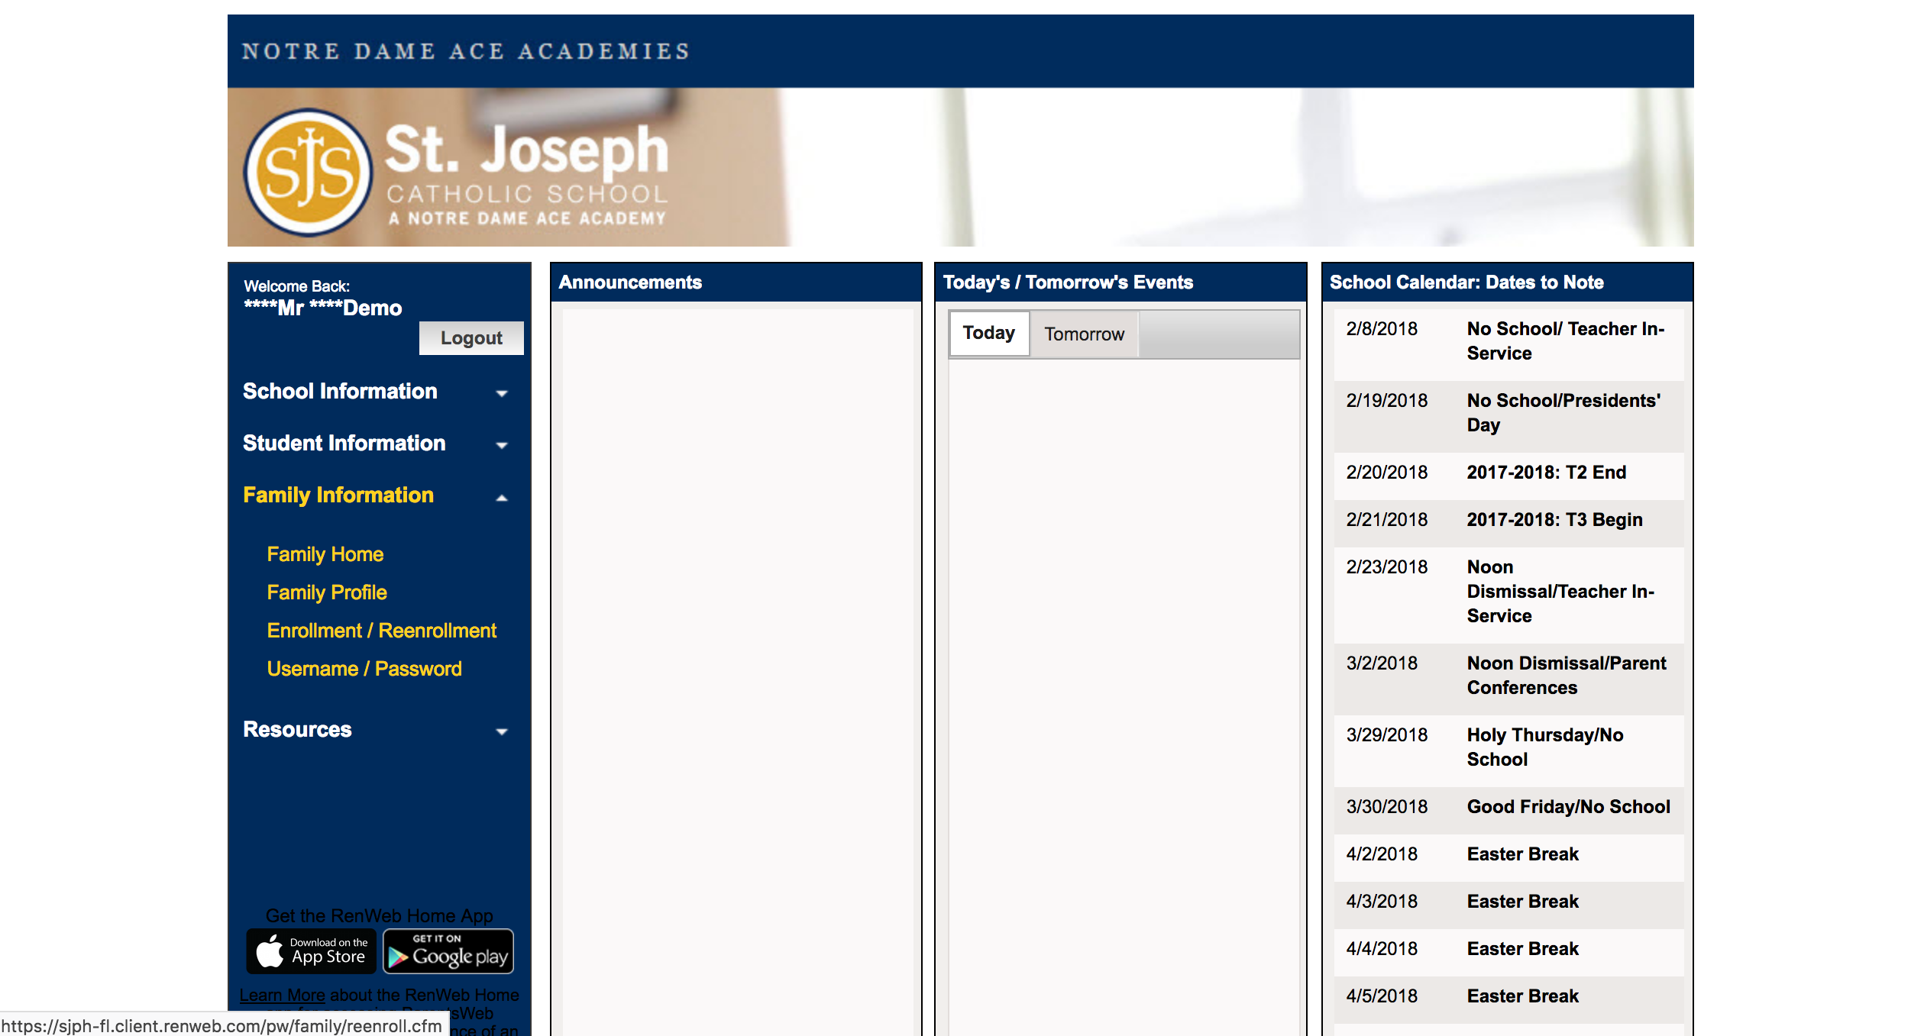

- Click Start Enrollment Packet to Reenroll. Haga click “Start Enrollment Packet” para inscribir.
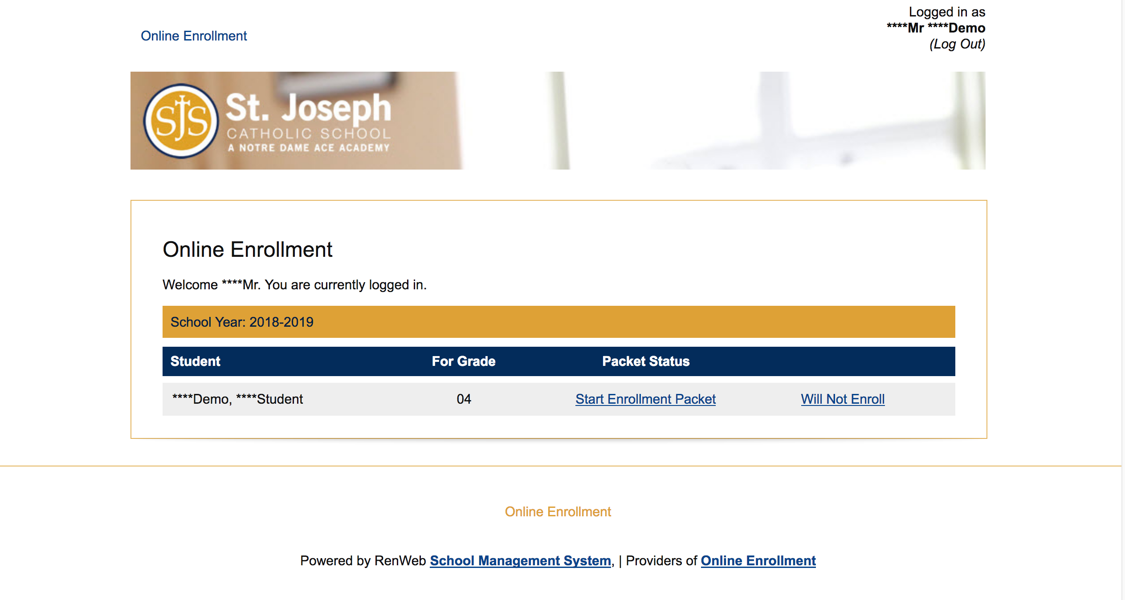

- Read the instructions on the first page. Click Next to go on to the next page. Leer las instrucciones en la primer pagina. Haga click Next para continuar a la proxima pagina.
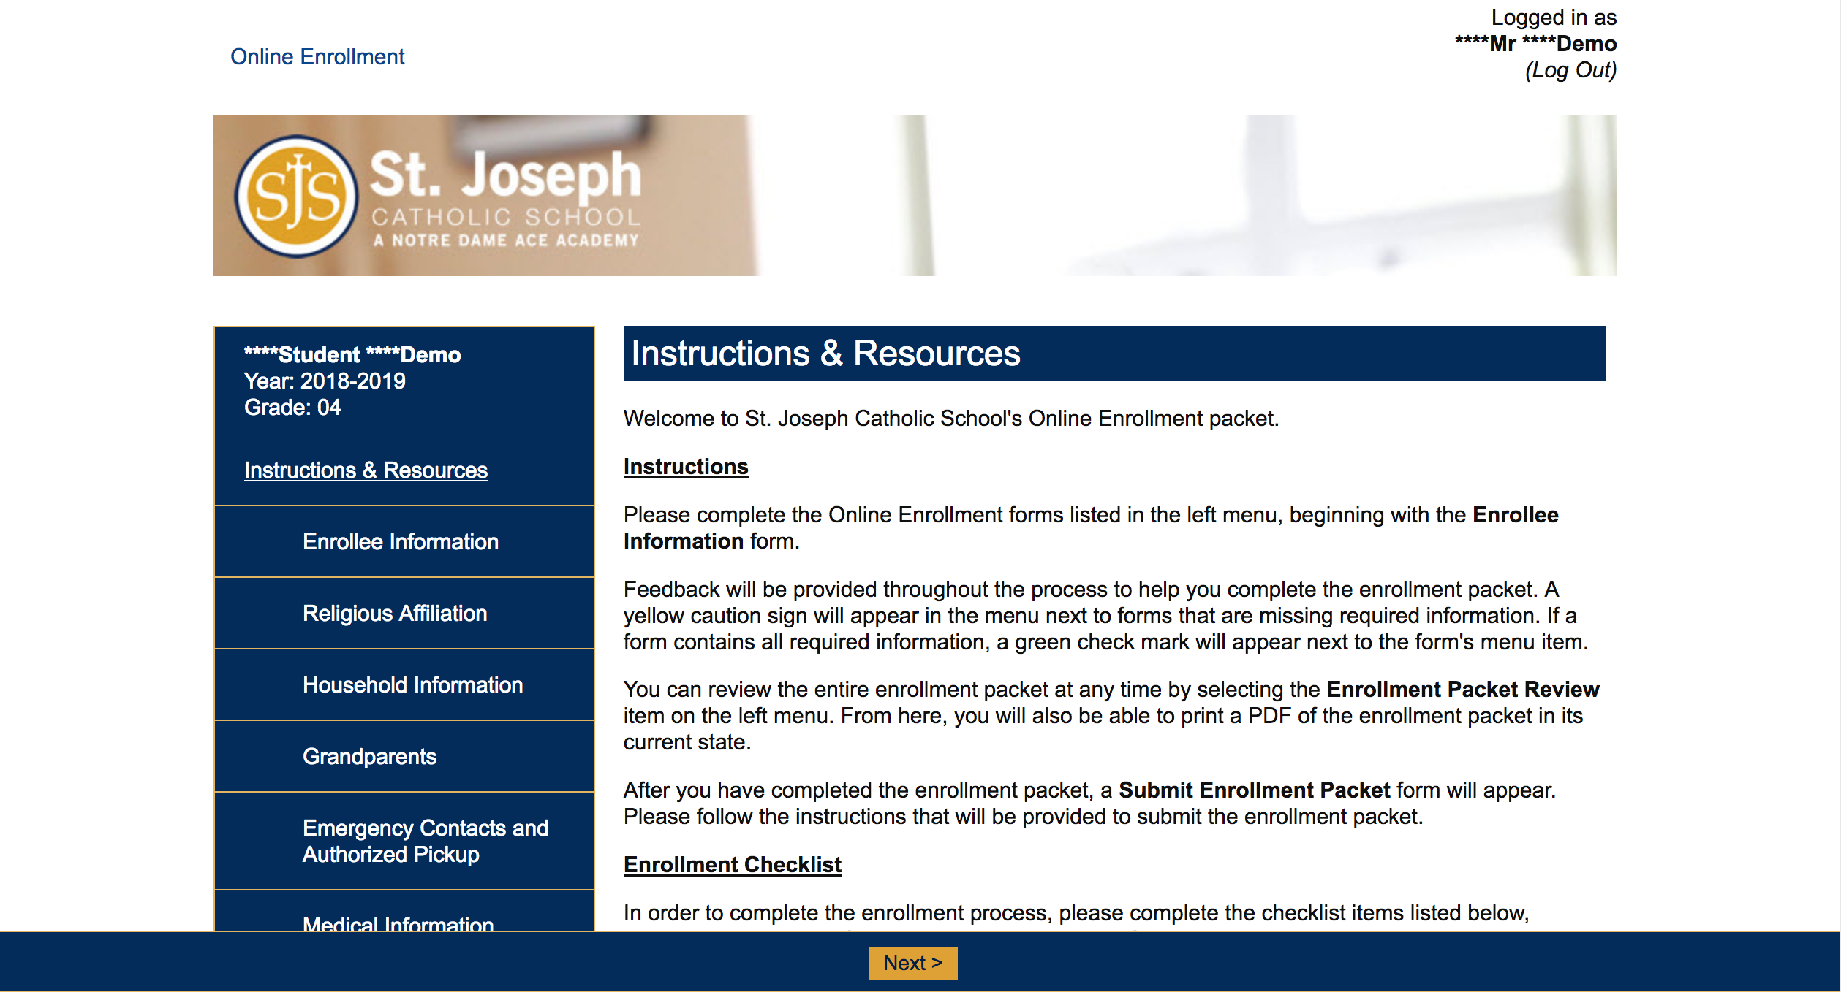

- When you finish a page, a green checkmark will appear. Incomplete pages will have a yellow exclamation point. When you finish a page, click Save & Next to move on. Quando termina un pagina, un marca verde de verificación aperecerá. Paginas incompletas tendrano un punto amarillo de exclamación. Quando termina un pagina, haga click Save & Next para continuar.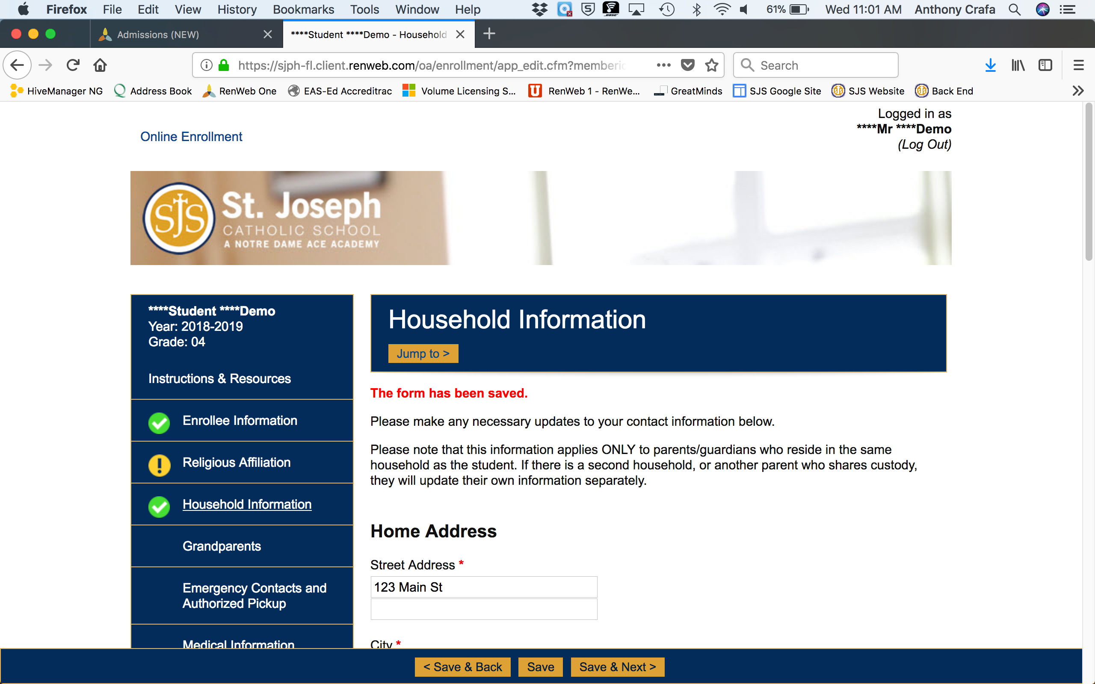

- When you are finished, submit the packet. You will receive an email that acknowledges your submission. Quando termina, envie el paquete. Recibirá un correo electronico que verificará el envio.

