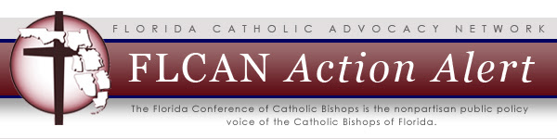
ACTION ALERT
Support Parental Empowerment in Education via Petition Drive
BACKGROUND: On August 28, 2014, the Florida Education Association, Florida School Boards Association, and several other parties filed a lawsuit, McCall v. Scott, claiming the Florida Tax Credit (FTC) Scholarship Program is unconstitutional. This is a serious challenge, and our concern is for the children who would be harmed if the program were ruled unconstitutional.
Florida's Catholic bishops have long supported the rights and responsibilities of parents as the primary educators of their children. In fact, Catholic schools in Florida were among the first nonpublic schools to embrace scholarship programs such as this one to extend opportunities to families which otherwise might be pushed to the margins of society. The program currently serves 68,000 children in Kindergarten to 12th Grade from low-income families.
ACTION: Earlier this month, a FTC Scholarship Program parent in Marion County started a special petition drive to show support for Florida's students who need these scholarships.
Show support for the FTC Scholarship Program by clicking here to sign the online petition.
MORE INFORMATION: For an additional perspective, please see a recent one-minute video which features a former FTC scholarship student named Denisha Merriweather. Watch Denisha's story here.
You can also see how Florida candidates in the November 4 general election stand on the issue of parental empowerment in education and several other issues of concern to the Church. See our 2014 Candidate Questionnaire Project.

201 West Park Avenue
Tallahassee, FL 32301-7715
phone: (850) 205-6820
fax: (850) 205-6849
email: info@flaccb.org
Visit our website

